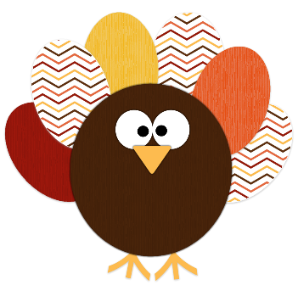
Preschool News
November

Singing in Church: This month we sing on ……….Church starts at 9:00. I hope to see you all there!
Picture Day: Picture retake day is Tuesday November 22nd. If you would like your child to have pictures re-taken, please send the picture packet back to school. For many preschool students this will be their first picture.
Scholastic Book Order: November book orders were sent home this week. Feel free to order as many or as few books as you would like. Any books that you order through our scholastic program earn points for books to be ordered for our classroom! To order online use the code: PB7VM. If you don’t have internet access you can still send the form along with correct payment (checks made out to scholastic) back to school in your child’s folder. Please place all orders by Nov. 11th.
Student of the Day: Remember to watch for the day that your child will be student of the day! Below you can see the number of students that preschool currently has per day so that it’s easier for you to plan a snack for your child to bring. Also never be afraid to call with questions.
Monday- 11 Tuesday- 18 Wednesday- 16 Thursday- 18 Friday- 11
Grandparents’ Day: We are looking forward to Grandparent’s Day! (THIS WEDNESDAY, OCTOBER 26th STARTING AT 9:30) Students have been working hard on their program for grandparents and relatives. This year’s program has a patriotic theme! We will have a special chapel service and program along with grades K-2. Lunch will be available following the program for $3.00 per person.
Parent Teacher Conferences: Parent teacher conferences take place every year in November and then again in the Spring. Fall conferences allows us to discuss where your child is right now, what your goals for the year may be, and gives an opportunity to discuss any concerns you may have. Please return conferences forms and then watch for a note coming home telling when your conference is scheduled.
THANK YOU MISS ZANK: Miss Zank’s last day in the classroom will be Friday, Nov. 11th. Mrs. Allard will start again on Monday the 14th. We want to thank Miss Zank for keeping everything running smoothly the past few weeks! It seems like there has been lots of fun learning going on in preschool this fall!

Mrs. Allard and Miss Zank
preschool@stjohnsneillsville.com
Mrs. Allard: 715-937-7535
Miss Zank: 715-937-5144

